Andreas Reisenbauer
born in Wiener Neustadt, Austria, Andreas Reisenbauer graduated in physics and chemistry from the University of Vienna. Later he began to study astronomy, film and theatre science, music and journalism. He works as a teacher of media studies. In the last 10 years he directed, wrote, edited or produced more than 30 short films and 7 feature films. He has never been supported by public film funding system till now.
In 2011 he cofounded the Austrian Independent Filmfestival (www.austrianfilmfestival.com) in Vienna, which he is heading in 2016.

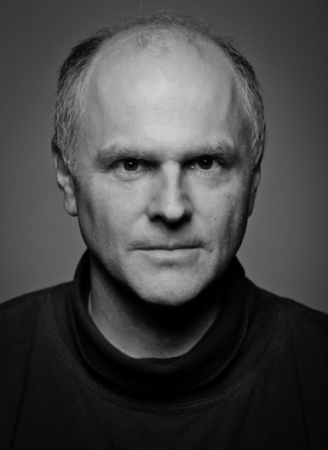
Internet movie database: www.imdb.com/name/nm2391548

Filmography (more see here: reisenbauer-film.com/film)

DIRECTOR/WRITER/ PRODUCING/EDITOR:
Traceroute (A 2016, 120 min) dir: Johannes Grenzfurthner (coproducer)
Precious Gift (A 2016, 9 min) dir: Andreas Reisenbauer (writer, director, producer)
Valossn (A 2016, 84 min) dir: David Hofer (producer)
Fairy Tale (A 2015, 2 min) dir: A. Reisenbauer, Stefanie Wanzenbeck (director, music)
Die Vertretung (A 2015, 9 min) dir: Markus Wimberger (writer, producer)
Causality (A 2014, 4 min) dir: Sonja Presich (writer, sound, producer) Cannes SFC 2015
Mind Candy (A 2014, 19 min) dir: Olivia Klonfar (sound ass., assoc. producer)
I Dono (A 2014, 3 min) dir: A. Reisenbauer, Andrea Tiziani (writer, director)
Wand vor der Wand (A 2013, 99 min) dir: Renate Woltron (coproducer)
Belly Landing (A 2013, 5 min) dir: Andreas Reisenbauer (writer, director, editor, sound)
Exit Koma (A 2013, 5 min) dir: D. Hofer, M.Weilguny (writer, coproducer, sound) Cannes SFC 2014
Giftnovelle (A 2013, 75 min) dir: Manuel Hölzl (camera 2nd unit, sound ass.)
Grenzwache (A 2013, 5 min) dir: Juliana Neuhuber/Markus Weilguny (writer, assoc. producer)
First Sight (A 2012, 3 min) dir: Juliana Neuhuber (writer, sound advisor)
Frauenquote (A 2012, 3 min) dir: Andreas Reisenbauer (director, ass. editor, camera, sound)
Gefällt mir (A 2012, 5 min) dir: Renate Woltron, A. Reisenbauer (director., ass.writer, editor)
Let me try again (A 2012, 82 min) dir: Gerhard Fresacher (coproducer, sound ass.)
Randgänger (A 2012, 87 min) dir: Renate Woltron (coproducer, editor)
Across the Mile (A 2011, 89 min) dir: Michael Thomas, Renate Woltron (coproducer)
Don Rudolfo (A 2011, 10 min) dir: Chris Dohr (editor, post producer)
Katharsis (A 2010, 89 min) dir: Kawo Reland (writer, producer, editor, foley artist)
Zeitsprung (A 2009, 8 min) dir: Andreas Reisenbauer (director, writer, music, prod., composer)
wins “Best Austrian Short Award” (Festival of Nations A 2010)
“Best International Short Award” (Patras GRE 2011) +about 30 festival participations
Business as Usual (A 2009, 22 min) dir: Kawo Reland (writer)

Contact:
Andreas Reisenbauer
Film- und Multimediaproduktion (e.U.)
Wallensteinstrasse 57/10. A-1200 Vienna - Austria

email: reisenbauer@gmx.at
telefone/fax: 0043-1- 2120973
mobile: 0043-699-1-210-1653
www: www.reisenbauer-film.com production page
www: www.reisenbauer.com personal page

